
Assignment 2: Industry Talk (PPG)

Subject : Technology and Information System (SECP1513)
Session : 202520261
Section : 01, 02, 03, 04, 05, 06, 07, 08, 09
Task : POSTER on INDUSTRY TALK 1
Title : Overview of PPG, Data Analytics, Infrastructure, SAP
Due Date : 5 December 2025 (1 week)
Submission : TEAM representative upload softcopy poster via e-learning

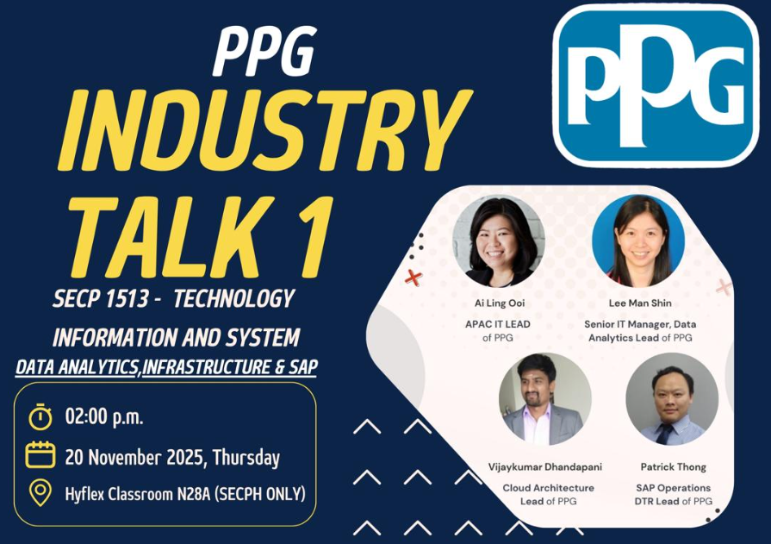

2.30 – 2.40 pm – Introduction to PPG by Ai Ling Ooi, APAC IT Lead
2.40 – 2.55 pm – Data Analytics presentation by Derrick Tan Horng Shi, Data Analytics Manager
2.55 – 3.10 pm – Introduction to Global Infrastructure by Vijaykumar Dhandapani, Cloud Architecture Lead
3.10 – 3.25 pm – SAP Introduction by Patrick Thong, SAP Operations DTR Lead

Instruction:

- Each team are required to prepare ONE poster on Industry Talk 1.
- The poster should include an executive summary, introduction, content based on the issues discussed in the talk, and reflection (see rubric of poster).
- The poster will contribute 7% of the course assessment.
- Size of poster is of A4 size. You may include diagram in your poster.
Note: the most important content of your poster, is your own opinion and views.
- Every team should design the poster using your own creativity.
- Every team should write the poster content using your own words.
- At the bottom of the poster, include the names, matric card and photos of your group member.
- PLAGIARISM of the content is prohibited. If any of the content is known to be copied from other website/review/blogs, you will be given 0 mark.
- You can get photos/information from other resources, but you must include credits (in citation/link) to the original owners.
Rubric for poster

Criteria | Excellent  10-7 | Fair  6-4 | Poor  3-0 | WEIGHTAGE | MARKS
Informative and Attractive | - Provide accurate and complete information (content).  - All required information is presented in a logical order. | - Some information (content) is incomplete, inaccurate, but presented in a logical order.  - Very few required information are missing and presented in a logical order. | - Most Information (content) are incomplete, inaccurate, or not presented in a logical order, making it difficult to follow.  - Most required information are missing and not presented in a logical order, making it difficult to follow. | 10 | ____ X 10  10
Contents | Report contents: Executive Summary, Introduction, Content of Talk, Reflection etc. |  |  | 20 | ____ X 20  10
Contents | - All contents included | - Included but not well covered | - Included but poorly covered | 20 | ____ X 20  10
Content Poster  - Presentation  - Graphic | - Very good presentation of content poster and well organized.  - Use many graphics, pictures. | - Moderate presentation of content poster and well organized  - Use moderate graphics, pictures. | - Lack of content poster and not organized properly.  - Use inappropriate graphics or pictures. | 10 | ____ X 10  10
Reflection | What is the motivation/insights/information did you gain from this career talk on how the jobs in Information Communication Technology (ICT) is essential to play a meaningful role in industry? |  |  | 30 | ____ X 30  10
Reflection | - Excellent explanation of point 1 and 2. | - Fair explanation of point 1 and 2. | - Poor explanation of point 1 and 2. | 30 | ____ X 30  10
Design  - Creativity  - Color Harmony | - Excellent design with high creativity.  - Presentation looks neat, professional and well- organized.  - Images, pictures, and clip art and drawn artwork are mostly colorful and appropriate.  - The layout is very creative. | - Moderate design with some creativity.  - Presentation looks fairly, but follows the formatting rules.  - Images, pictures, and clip art and drawn artwork are colorful.  - Layout shows some degree of creativity but is not organized logically and/or is cluttered. | - Design with lack of creativity.  - Presentation looks untidy but violates some formatting rules.  - Colors are inappropriate and artwork shows little creativity.  - The layout is messy, disorganized or cluttered. | 10 | ____ X 10  10
Organisation and Structure | - Structure of poster is interesting and organised very well, easy to understand. | - Structure of poster is quite interesting and organised. | - Most parts of the structure of poster are not really interesting and unorganised. | 10 | ____ X 10  10
Text | - All text is easy to read.  - Use appropriate font size.  - Use not more than three different font styles. | - Most text is easy to read.  - Use appropriate font size.  - Use more than three different font styles. | - Some texts are difficult to read.  - Use medium font size.  - Use more than four different font styles. | 5 | ____ X 5  10
Submission | - Submit on time | - Submit one day late | - Submit more than one day late | 5 | ____ X 5  10
 |  |  |  | Total | / 100

